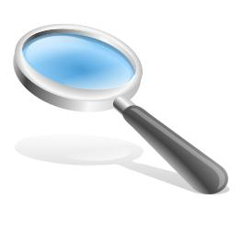

Website Credibility
Names of group members: Period:
Group #:

Accuracy
Is the information supported? (sources)

Currency
Evaluate publication date.

Navigation
How quickly can we predict where to find the information?

Is the information easy to find?

Objectivity
Can you conclude whether or not opinions were included in the information?

Credibility
Does the website have a credible author? (research about author, credentials, what associations does this person belong to)?

Does the website have any endorsements?

Authenticity
Does the website information give statistical data? (research backing)

Purpose
Is the purpose of the website to give factual information?

Coverage
As a reader, do you have the whole story?

